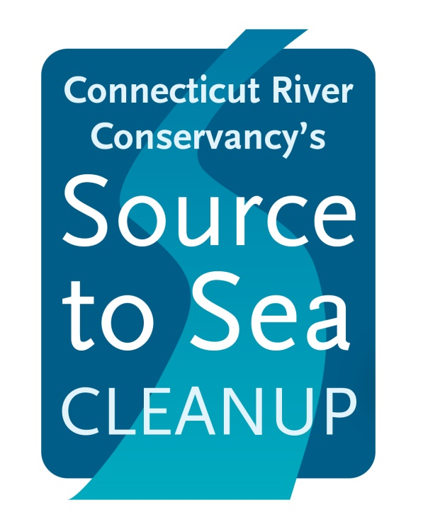

Get your feet wet, your hands dirty

& make our rivers cleaner!

FRIDAY & SATURDAY

September 27 & 28, 2019

All are welcome.

**Join thousands of individuals, clubs, scout troops, students, towns and businesses to clean up the Connecticut River and its tributaries. The Source to Sea Cleanup is a coordinated effort in four states for cleaner rivers.**

**We need your help!**

**Contact your local cleanup group at:**

**WHAT TO WEAR**

Mud Boots

Pants & Socks

Long Sleeve Shirt

A PROGRAM OF THE CONNECTICUT RIVER CONSERVANCY **WWW.CTRIVER.ORG/CLEANUP**

**WHAT TO BRING**

Water

Extra clothes Bug spray

Friends & Family

Enthusiasm

**WE WILL SUPPLY**

Trash Bags

Gloves

Appreciation