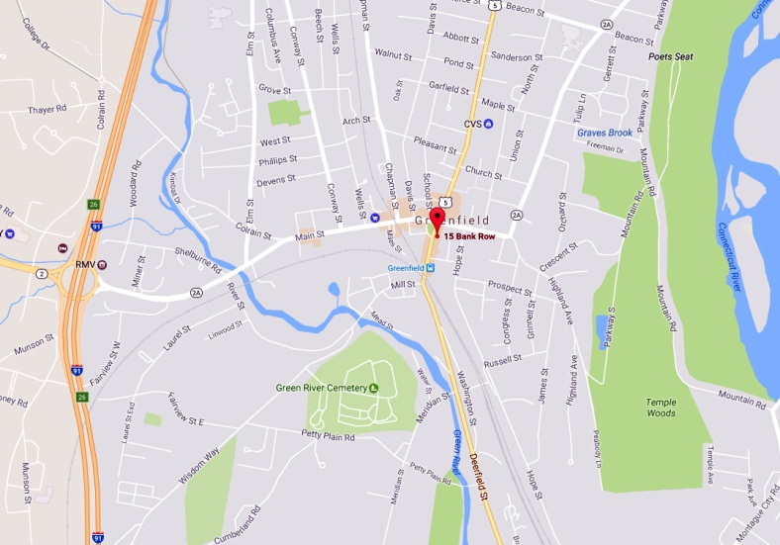

**Our Headquarters in Greenfield, Massachusetts**

The Connecticut River Conservancy’s main office is located in the center of Greenfield, right on the common, in the historic E.A. Hall Building which was built in 1813 as the first Franklin County Courthouse. The Conservancy purchased the Hall Building in 1999. The building is now fully renovated and handicapped accessible with a conference room and 5,000 volume library. We invite you to stop by.

**From Interstate 91 (North & South):**Take Exit 26 to rotary and Route 2A East, toward Greenfield Center. Head east on Route 2A (Main Street) 1.3 miles to intersection of Federal Street/Bank Row with Main Street. Turn right onto Bank Row – 15 Bank Row is on the left, just past the defunct bank.

**Parking:**There are metered 2-hour spaces on the street across from the Conservancy, and more along the street downhill from the office. To use a nearby parking lot, go downhill on Bank Row to the first left on Olive St. Ahead of you at the end of Olive Street is the Hope Street Lot with 10-hour spaces and kiosks (buy a coupon and leave it on your dashboard).