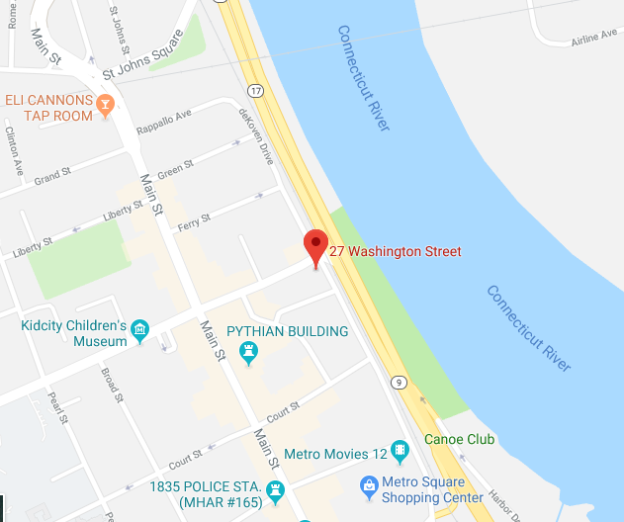
Our offices in Middletown, CT
THE DEKOVEN HOUSE
27 WASHINGTON STREET,
MIDDLETOWN, CT 06457
From New Haven and points South:
Take I-91 North to Route 66 East. Stay on Route 66 (Washington Street) into Middletown. Just after you cross Main Street turn into Piazza Melilli Municipal Parking Lot and park. The deKoven House, a brick mansion, is just to the east on the right, before the Route 9 intersection. *PARKING IS ALSO AVAILABLE AT NIGHT ONLY IN THE MUNICIPAL LOT JUST SOUTH OF THE DE KOVEN HOUSE OFF DEKOVEN DRIVE.
From Hartford and points North:
Take I-91 South to Route 9 South (to Cromwell and Middletown). Get off at Exit 15 (Wesleyan University and Washington Street Exit). The deKoven House is immediately on your left past the railroad tracks. Park in the Piazza Melilli Municipal Parking lot immediately past the deKoven House on the left.
From Old Saybrook and Points Southeast:
Take Route 9 North. Take left hand Exit 15. The deKoven House is immediately on your left past the railroad tracks. Park in the Piazza Melilli Municipal Parking lot immediately past the deKoven House on your left.

